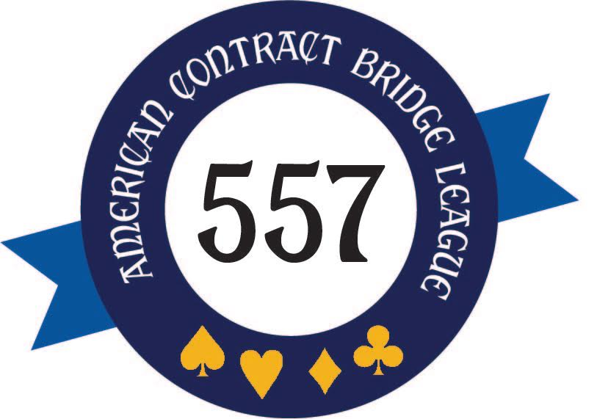

Long Beach Unit 557
Board Minutes
April 19, 2022

Call to Order: Lillian Slater, Vice President, called the meeting to order at 11:04 a.m.

Absentee Members: Sharon Biederman, Dalia Hernandez, Linda Leventhal, Bonnie Shok
Election of Officers: Members of the Board of Directors were elected at the unit game on March 20, 2022. New board members are Leo Dittemore, Linda Leventhal and Melanie Smothers. The following board members have been nominated as officers:
Lillian Slater-President
Chuck Laine-Vice President
Jenny Ernest-Treasurer
Linda Leventhal-Secretary (trial)

A motion to elect the nominated officers was made, seconded, and unanimously approved. As the new president, Lillian resumed the regular meeting.
Minutes: A motion was made, seconded, and unanimously passed to approve the March 15, 2022, minutes.

Hospitality Report: Bonnie reported by email. She sent one get well card.

Treasurer’s Report: Treasurer Jenny Ernest presented the March financial report:

Beginning Checking Account (3/1/2022) $14,614.33

Income (Unit Game proceeds) 273.00
Expenses (Unit Game expenses) (310.71)

Ending Checking Account (2/28/2022) $14,576.62*

*The unit also keeps $200 in petty cash for use at unit games and tournaments, plus $23 collected for charity.

Club/Bridge Brigade Update: In Sharon’s absence, Lillian highlighted some known status:
- Supervised Play on Monday, Tuesday and Wednesday mornings has been well attended.
- The club is offering a Stay and Play Discount to $5 for anyone attending a class and staying to play after.
- Ardie Laine has taken over the calendar.
- On Tuesday, June 7th, at 9:30 a.m., the club plans to hold its first Pro-Am since the pandemic.
- On Friday May 20th, Dalia Hernandez is presenting a free workshop on Navigating Tournaments.
- Team Games will be scheduled on the 3rd Sunday of each month for the remainder of the year.

Unit Game: Our next Unit Game will be Sunday April 24th, at 12:30 p.m. We will also present awards at this game:
- Alan Flower will be the director.
- Lillian will make the boards.
- Lillian and Jenny will assist with registration.
- There will a199’er section for $2 if two or more tables of qualified players attend.
- Judy Jones will advertise the unit game at Leisure World.
- Lillian has emailed the flyer to people who play in other clubs.
- Ace of Clubs and Mini-McKenney award winners will receive unit free plays. Discussion clarified that the Free Plays can be redeemed only at unit games but may be transferred to other players if the recipient so desires.
- Charlotte Roush volunteered to handle the ordering/pickup of a Costco cake for refreshment. Fern Dunbar suggested it say “Congratulations” to the winners.
- Proof of vaccinations is required. Masks are optional.

The first unit game in two years was held on Sunday, March 20th.
- Sixty people attended but this was lower than the pre-pandemic numbers. It may be partially due to the late notice about the game, as well as reduced table counts in general as we emerge from the pandemic.
- Lower attendance coupled with redeemed Free Plays resulted in a $37.71 loss to the unit.
- Chuck Laine noted that the club had 600 tables in the first quarter of this year, which would annualize to 2,400. This compares to our 6,000 per year pre-pandemic but is reflective of what’s happening elsewhere.

Leisure World: Judy Jones provided a status update:
- Larry Slutsky has been elected the president of the Leisure World Bridge Club.
- They operate games Monday, Thursday, Friday, and Saturday for $5/game.
- They averaged 7+ tables/game in March.
- They are starting to enforce a 50% guest max.
- They are changing their reservation system, and a new contact will be provided in future. Jenny needs it for the Welcome letters.
- Rob Preece will teach Beginning Bridge starting Friday April 22nd, to Leisure World residents only
- They are seeking Directors.

New Business: Lillian indicated that, while making the boards, several older decks had issues with the dealing machine. She requested that $100 be allocated to purchase some replacement card decks. A motion to do so was made by Alan Olschwang, seconded by Fern, and unanimously approved.

Adjournment: A motion was made by Alan and seconded by Charlotte to adjourn the meeting at 11:52 a.m.

Next Unit Games: Sunday, April 24, 2022, at 12:30 p.m.

Next Meeting: Tuesday, May 17, 2022, at 11 a.m.

Respectfully Submitted: Rita Vanlierop

